Comments and Remarks As received from client on 23 December 2024:
- Login Page
  - Change the position of Login Panel and the animation Video (Login panel at left, animation at right of the screen). Sample provided below:

- Splash Screen
  - Application name is : Admin Property & Asset Management System [*Remove A3MS from its name]
  - 5 seconds (minimum) hold of splash screen.
  - Provide an animation (fading screen) when the splash screen is closing.
- Zone and State Boundary
  - Remove state boundary from the ZONE boundary. Only Zone boundary will be visible at the INDIA extent.
  - The STATE boundary and name will be available on zooming in on the screen.
- Home Screen
  - The application name is : Admin Property & Asset Management System.
  - Also provide the White translucent box behind the right-side icons as well. Sample screen will be as follows:
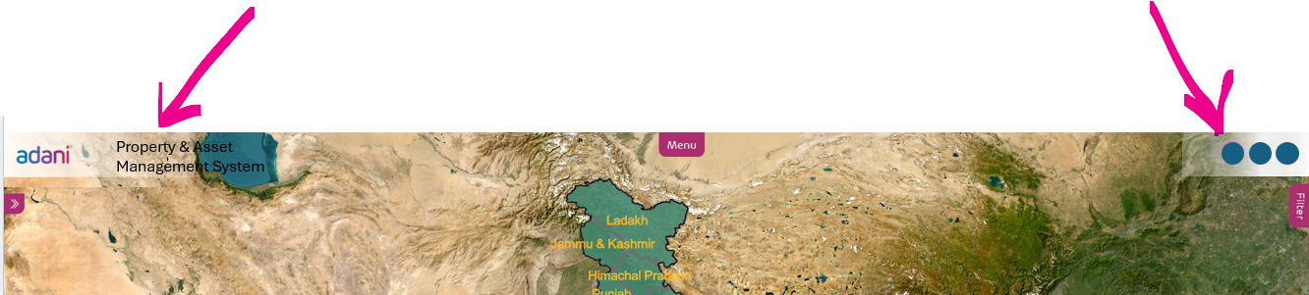
  - The 'Manage' option will be transferred to the 'User Profile' Icon:
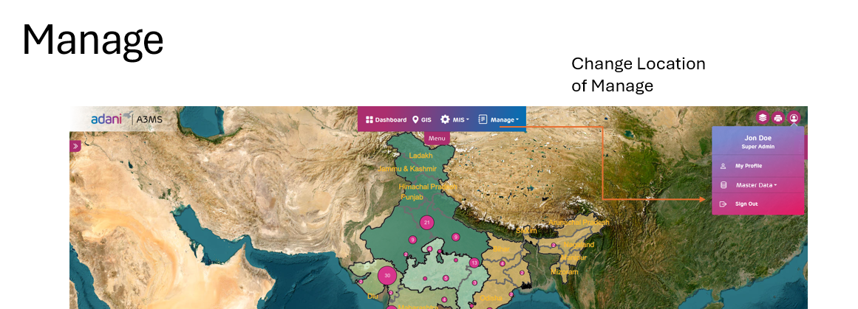
  - Remove GIS Icon, there will be no need for GIS panel
  - Provide a TOOL option with following functions:
    - Measurement
    - Buffer
    - Query Builder
    - Map Export
  - Increase the transparency of both the panels (Summary and Filter)
  - Remove the excess gap between the white translucent box and panels, as shown in the image below:
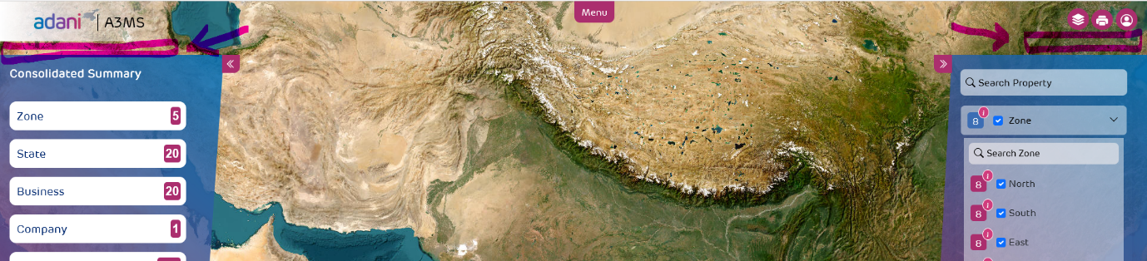
  - Zoom in and Zoom Out Button on the Screen:
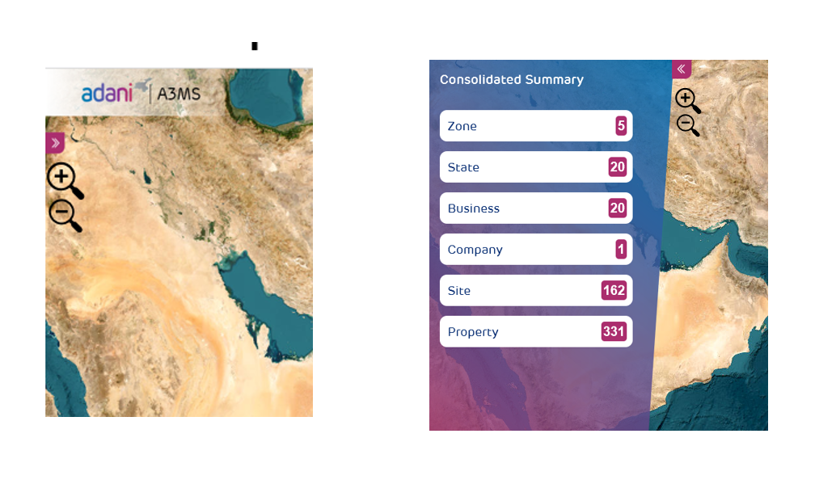
  - Summary and Filter Panels:
